Gunner Milligan survives a 'stonk'

8th April 1943: After the war popular comedian Spike Milligan was able to recall events in Tunisia with a sense of humour
APR 8

SAVE |  | ▷ LISTEN

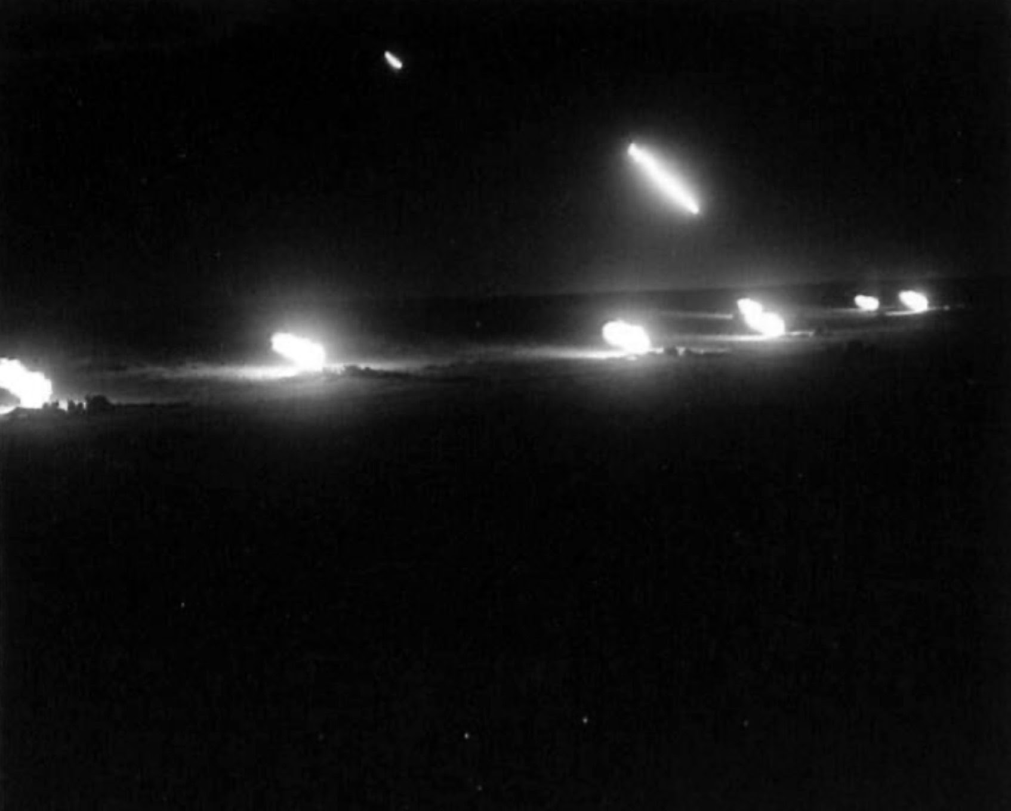
The night barrage that preceded the Eighth Army's attack on the Gabes Gap. 4.5 guns of the 64 Medium Regiment R.A.
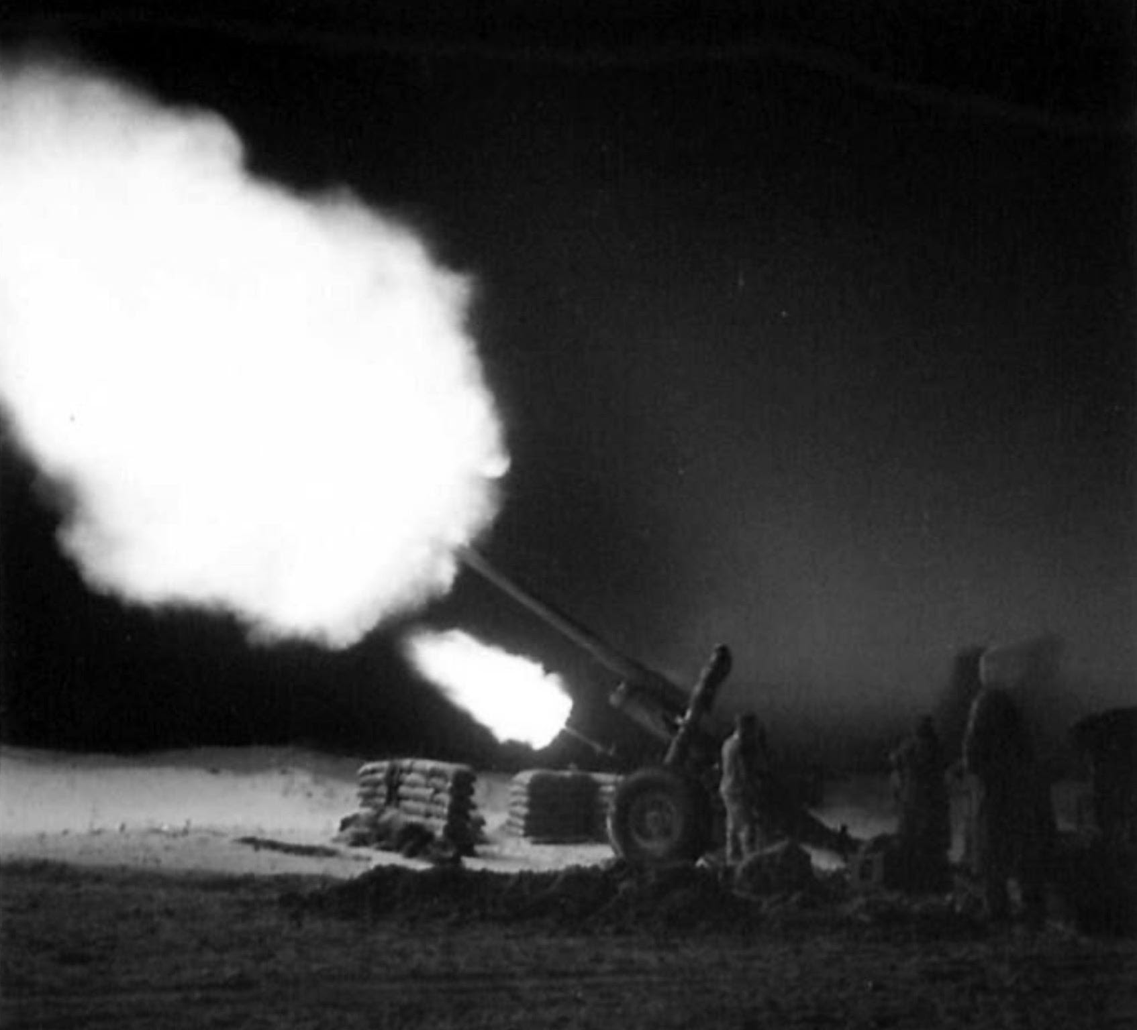
4.5 Guns of the 64 Medium Regt. R.A. pounding the enemy positions at dawn.
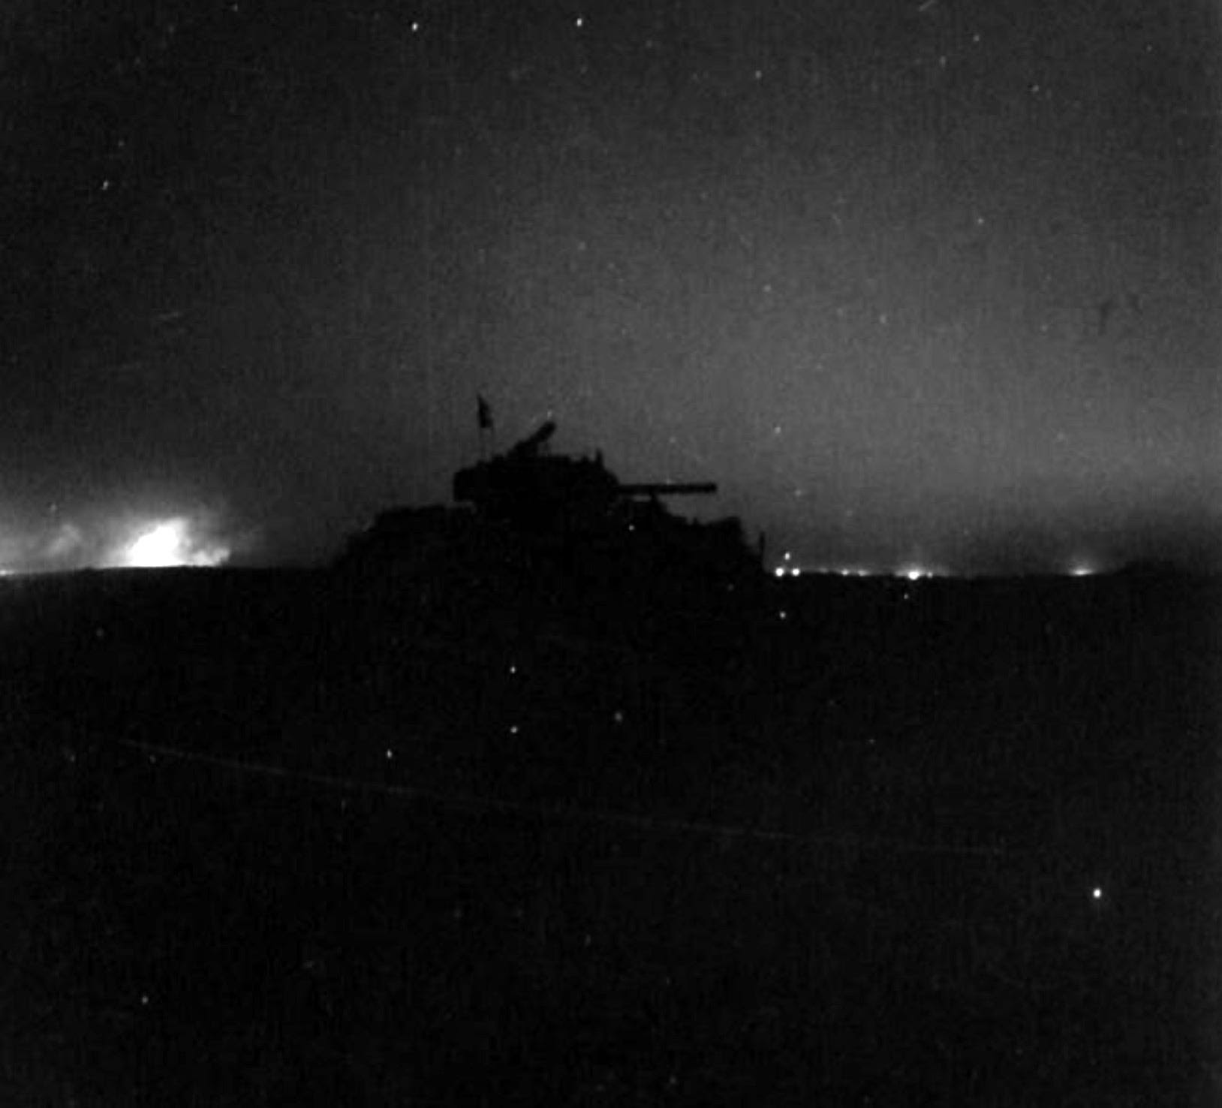
Just as dawn begins to break, the tanks go into attack A Sherman silhouetted against the sky still lit by the flashes of the 8th Army's barrage.
In Tunisia the fighting went on as the Germans sought to make a fighting retreat. The British Eighth Army, which had fought its way all the way west from Egypt and the battle of El Alamein now met up with the U.S and British forces that had been moving east since Operation Torch. The Germans were now stuck on the Tunis peninsula, their position was untenable but there was no alternative but to keep fighting.
… the young officer was Goose-stepping and shouting in Cod German ‘Zis is our last Territorial demand in Africa.’ Behind him a stiff, bitter-faced Afrika Korp Oberlieutenant marched with all the military dignity he could muster…
Amongst these men was one man keeping a unique diary. In his subsequent memoirs, Spike Milligan¹ was to capture some of the humour that often kept the British soldier going through the worst of times. Yet his experiences in Africa were far from being one long joke:
April 8 1943:
Djbel Mahdi. Up at first light, drove in the wake of a hurried Jerry retreat along the floor of a hot dust-choked valley, we passed still burning vehicles - some ours, some theirs. A few carbonised bodies - ‘brew ups’ as Tank men called it. We stopped to pin-point our position, to my left, lying face down was the body of an Italian not long dead, the blood on his neck still oozing. Lovingly, I removed his watch.
The Bren stopped at the foot of Djbel Mahdi.
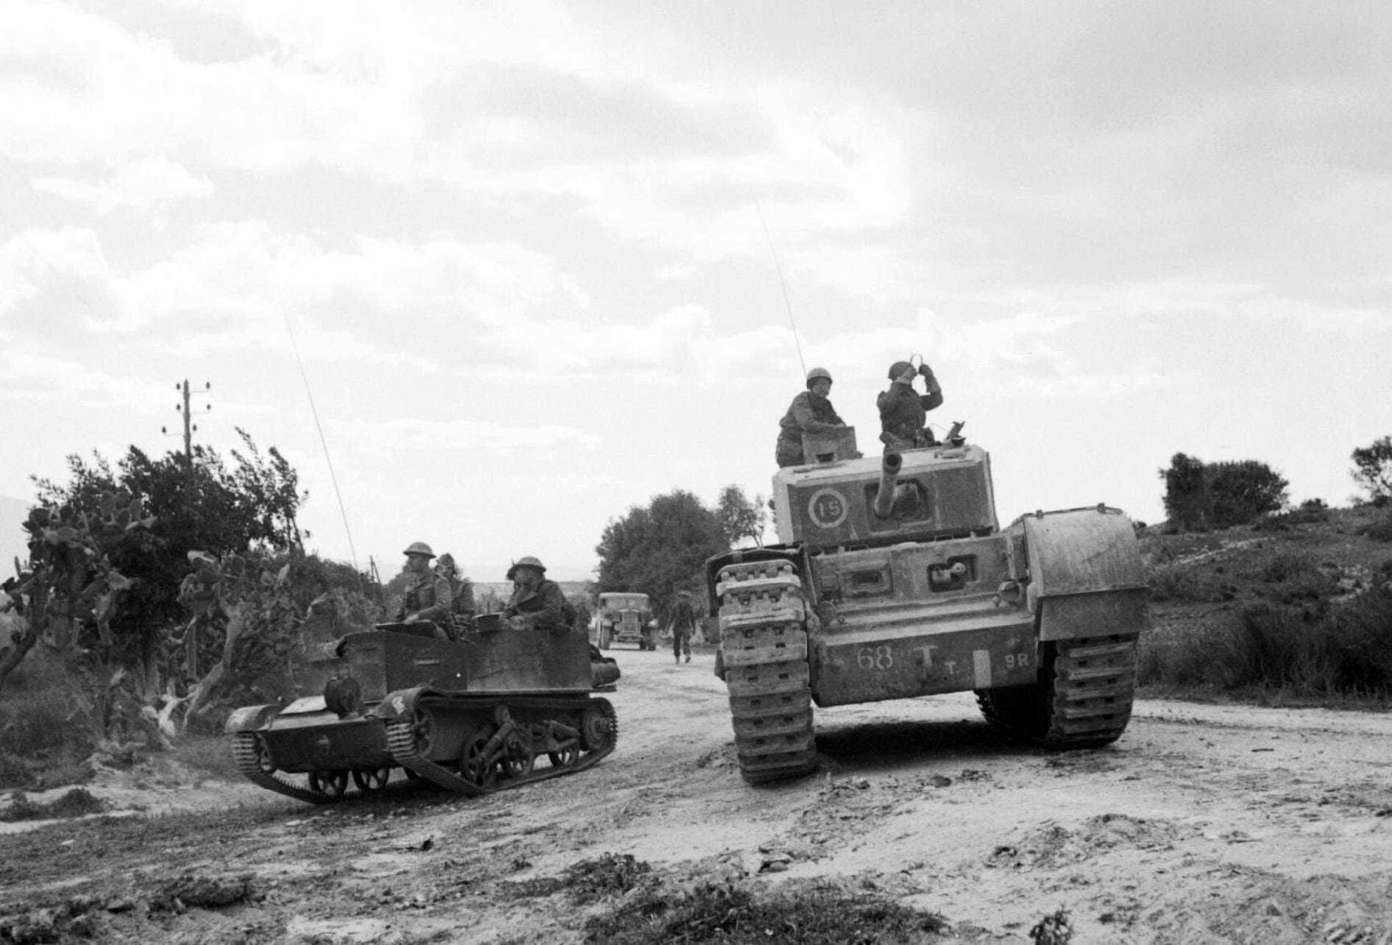
A Universal carrier [commonly known as a Bren gun carrier or simply Bren] and a Churchill tank of 51st Royal Tank Regiment during 6th Armoured Division's attack on the town of Pichon, 8 April 1943.
The 2/4 Hamps were still digging in when we arrived. I follow Capt. Rand and Bdr Edwards uphill, unreeling the remote control from the wireless. Fuck! it didn’t reach, Rand and Edwards dropped on their bellies just below the crest. I had to run back, fix them a telephone line that reached back to the remote control, so they shouted fire orders to me by telephone, and I passed them on by wireless.
We didn’t have time to dig in, and Christ! a German ‘Stonk’ hit us - it was a rain of shells. To stay where I was meant death, so I ran to an Infantry Officers’ fox-hole. ‘Any room for one more?’ I said. 'Sorry old boy, this is a one-man trench.’ I dived in head first as fresh shells landed. ‘Well now it’s a bloody two-man trench!'
I tell you! They are willing to let you die rather than move over! The shelling stopped. I got out and returned to duty - more shells - I found a small depression in the lee of some rocks.
‘Where are you,’ shouted a voice. ‘I’m in a depression,’ I said. ‘Aren’t we all,’ was the reply.
As they passed, our lads stood up in their fox-holes farting, and giving Nazi salutes; recalling the ritual of ancient conquerors riding on a palanquin and parading their prisoners of war behind them. Here there were shouts of ‘you square-head bastards’ and ‘I bet we could beat you at fucking football as well.’
So far we hadn’t passed any fire orders, it was very hot, I asked Maunders on the wireless if he had any water. Yes. I started to run down to get some. A fresh mortar barrage. I lay face down, sweating. It stopped. An infantry man stopped by me, God knows where he came from.
God: He came from the 2/4 Hampshire my son. Me: Ta.
The soldier delighted in telling me, ‘It’s no good hiding there, he’ll get you no matter what, if you haven’t got a trench, any minute now he should start his mortars, he dropped some this morning just where you’re lying.’ All this got my back up (which by now was down by my ankles). ‘Why don’t you fuck off and join the German Army?’ I thought he was going to shoot me but he cleared off.
I was learning the strange quality of the human race. His kick was to find somebody who looked scared, and try and make him terrified. I suppose he liked feeling little girls’ bicycle saddles as well. A Hampshire private popped his head up from a funk hole. ‘If they attack, do you think we can hold ’em?’ ‘Yes,’ I said confidently, ‘there’s a barrage going down at 2.’ ‘Oh good,’ he said.
I got some water from Maunders, then dashed up to my remote control in time to pass fire orders. It was 13.59 hours. At 14.00 the barrage went over followed by the infantry attack. From the crest I watched the P.B.I. going forward, down the slopes of Djbel Mahdi, across the valley and up the slope opposite.
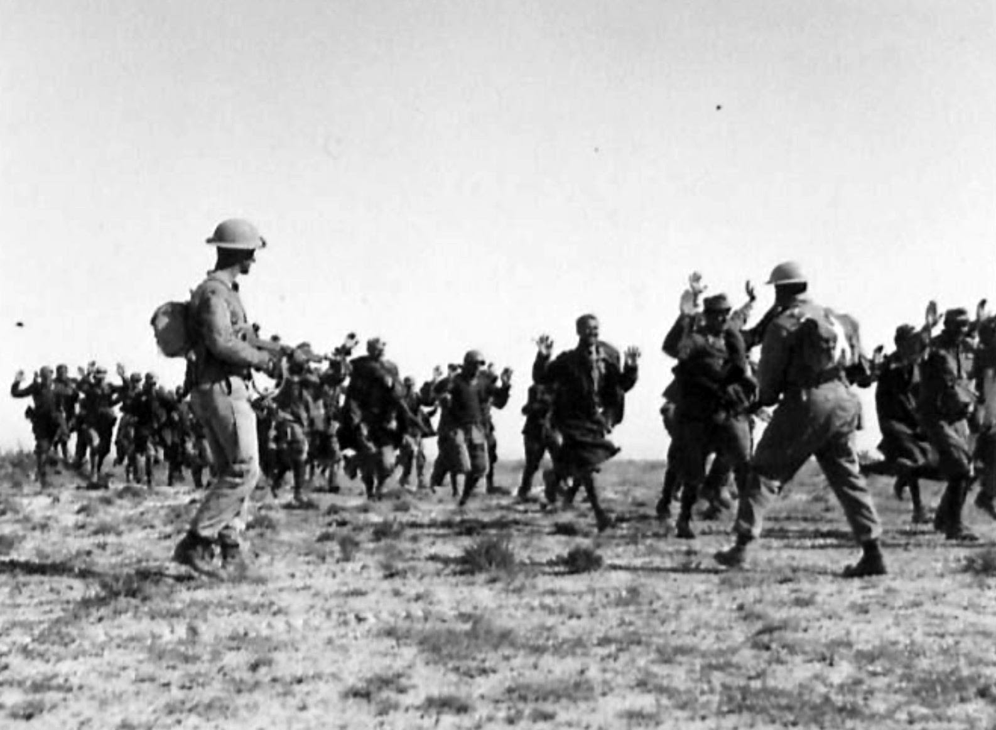
‘In they come at a jog-trot, Italians surrendering to the Highland Division.’
Men fell sideways and lay still, no one stopped, they reached the German F.D.L.’s, from the distance it looked comic. Men jumping out of holes with hands up, men running behind trees, leaping out of windows; it took about an hour. By 3 o’clock we had taken the position, but Jerry counter-attacked, we shelled him, and broke up the attack.
Around a hill comes a British Officer, clowning at the head of about 50 PoW’s from the 1/755 Grenadier Rgt, the young officer was Goose-stepping and shouting in Cod German ‘Zis is our last Territorial demand in Africa.’ Behind him a stiff, bitter-faced Afrika Korp Oberlieutenant marched with all the military dignity he could muster, none of his men looked like the master-race.
As they passed, our lads stood up in their fox-holes farting, and giving Nazi salutes; recalling the ritual of ancient conquerors riding on a palanquin and parading their prisoners of war behind them. Here there were shouts of ‘you square-head bastards’ and ‘I bet we could beat you at fucking football as well.’
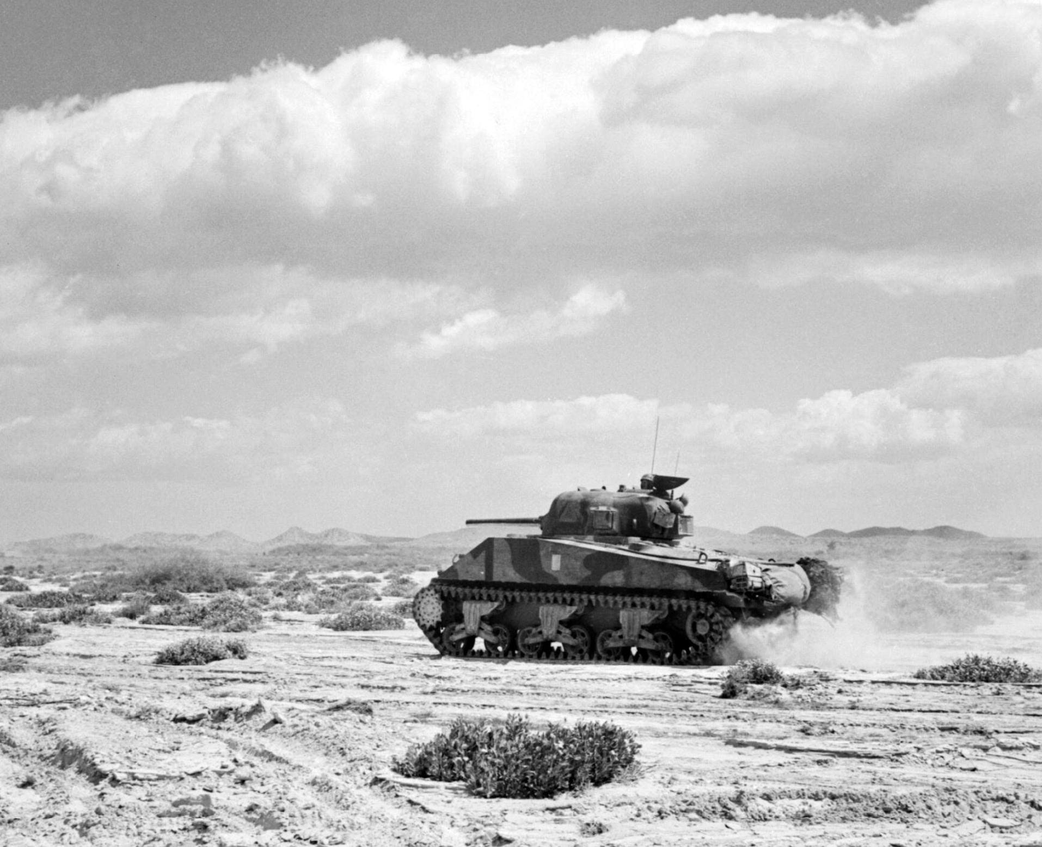
A Sherman tank advances at speed in the Foudouk Pass, 8 April 1943
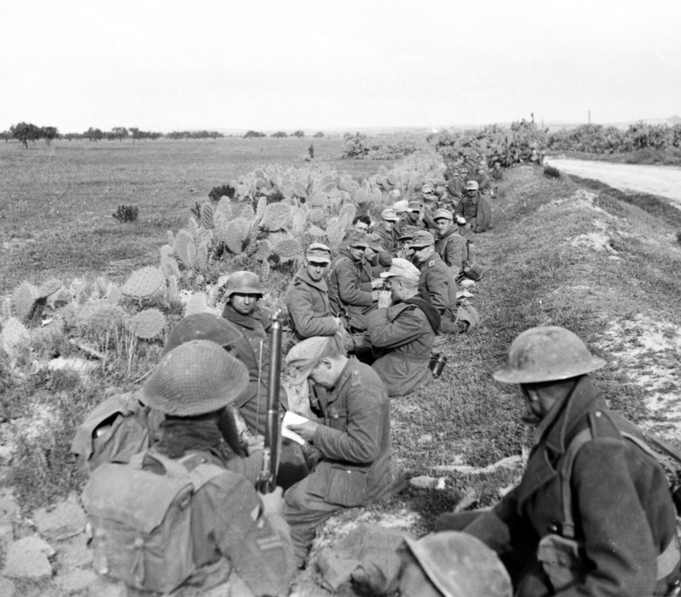
German prisoners and their guards wait in a roadside ditch during 6th Armoured Division's attack on the town of Pichon, 8 April 1943
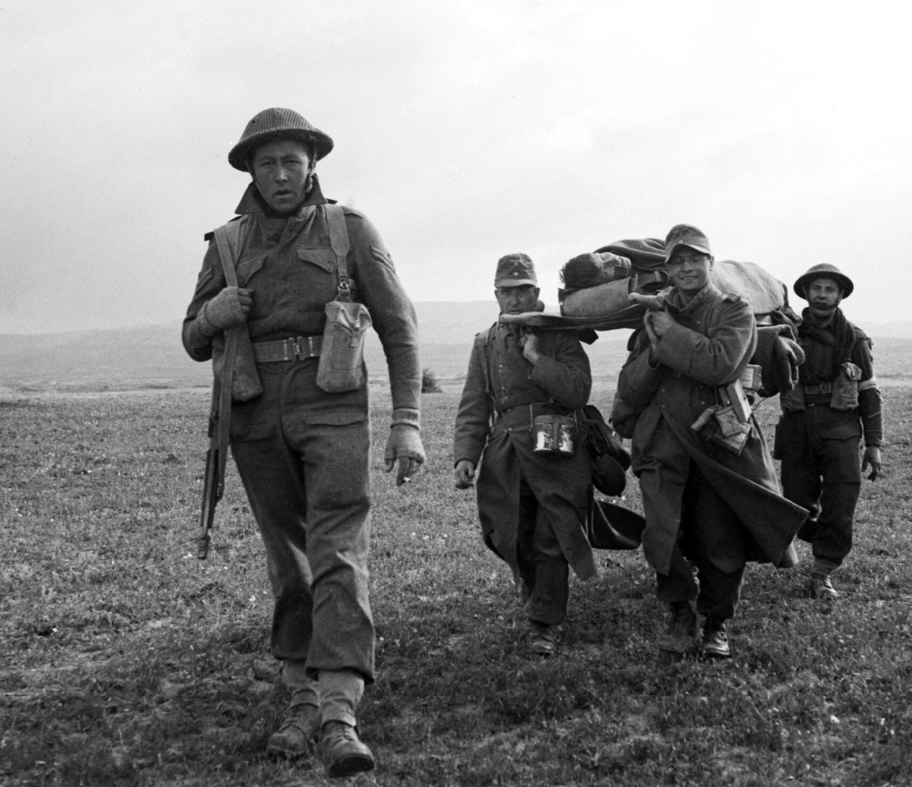
A soldier escorts captured Germans bringing in a stretcher during 6th Armoured Division's attack on the town of Pichon, 8 April 1943.
1
Rommel?' 'Gunner Who?': A Confrontation in the Desert (Spike Milligan War Memoirs)
LIKE |  | COMMENT |  | SHARE

